Student: Duong Le

IT 360

Oct 11, 2016

Assignment 4 - Sales

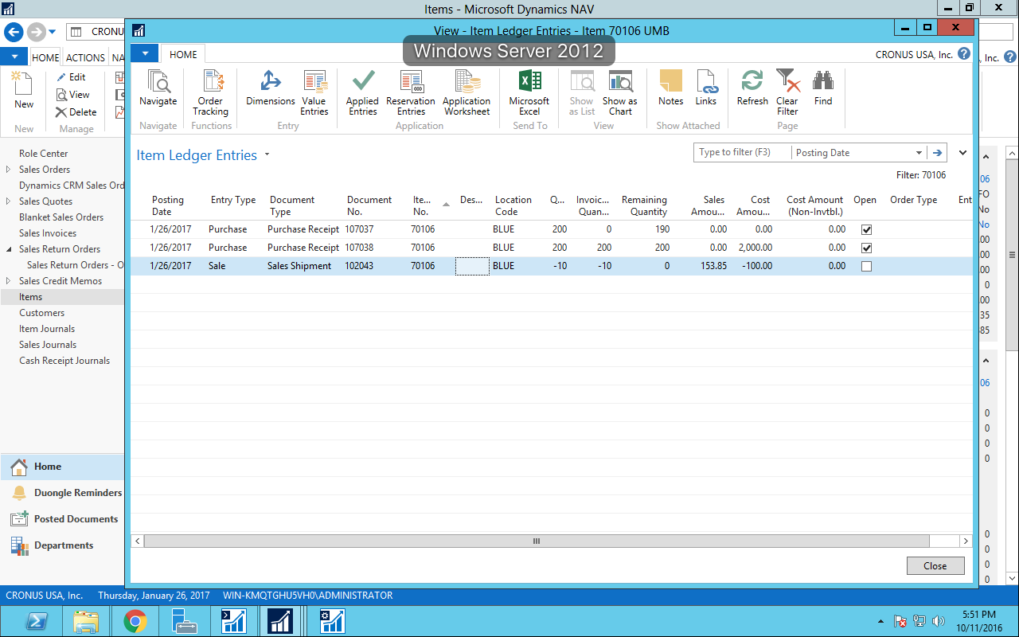

Item Ledger Entries

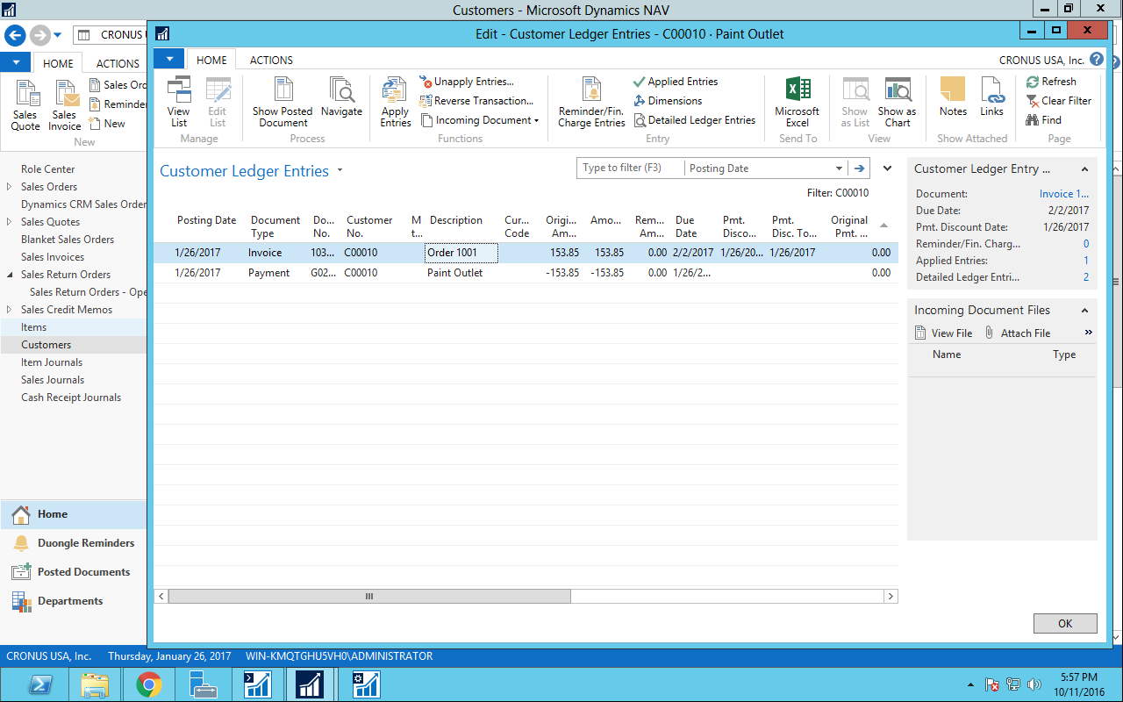

Customer Ledger Entries